Ai-Based Tunnel Rock Classification Model Survey

Part 1: Basic Information
This section outlines the demographic and background questions presented to all participants at the beginning of the survey.

1.1 Purpose of this Section
This section is designed to collect demographic and background data from participants. This information is essential for two main reasons:
- To understand and describe the composition of the participant sample.
- To analyze potential correlations between participant characteristics (e.g., industry experience, education) and their perceptions of the AI model.

1.2 Content as Presented to Participants
The following is the exact content and layout that was shown to the survey respondents.
Introduction
Dear Respondent,
Thank you for participating in our survey! We are an Artificial Intelligence (AI) research team from a university developing a model for rock classification in tunneling. To enhance its effectiveness, we kindly request your basic information and insights.
Please note that participants should have experience in tunnel construction management. Please fill in the following information based on your actual situation.
Questions
1. What is your gender?
[] Male
[ ] Female
2. What age group do you belong to?
[ ] 22-30 years old
[ ] 31-40 years old
[ ] 41-50 years old
[ ] 51 years and above
3. How long have you worked in the tunnel construction management industry?
[ ] Less than 5 years
[ ] 6-15 years
[ ] 16-25 years
[ ] Over 26 years
4. What is your highest level of education background?
[ ] High school or less
[ ] Associate Degree
[ ] Bachelor’s Degree
[ ] Master’s Degree
[ ] Doctoral Degree
5. What is your level of understanding of artificial intelligence?
[ ] Not at all familiar
[ ] Slightly familiar
[ ] Moderately familiar
[ ] Very familiar
[ ] Extremely familiar

Part 2: Experimental Conditions

2.1 Group 1: No Intermediate Layer Visualization (Control Group)

2.1.1 Purpose of this Condition
This is the control condition of the experiment. Participants in this group were shown the model's training process and final prediction results without any additional explanation of its internal decision-making logic. This condition serves as a baseline to measure trust and understanding when no interpretability is provided.

2.1.2 Content as Presented to Participants
The following is the complete training process and results of the model; please read it carefully.

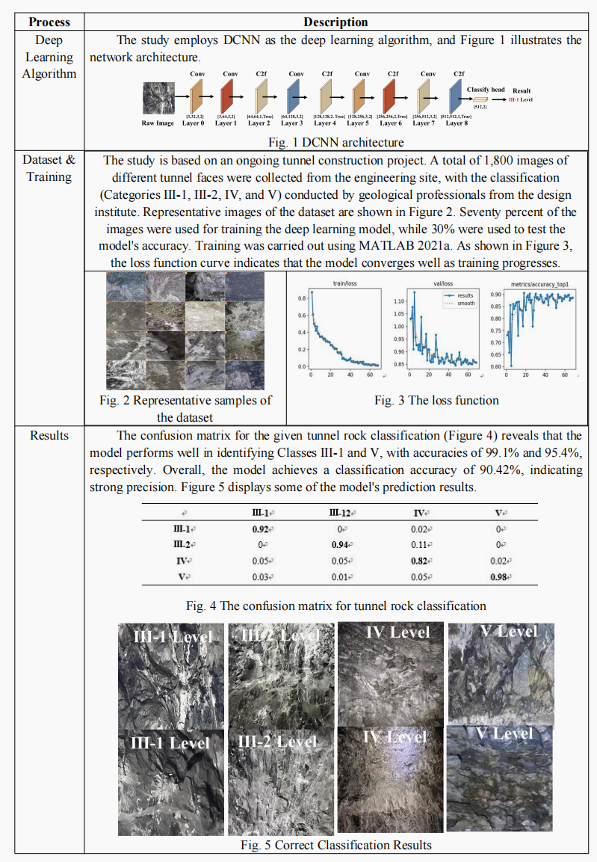

2.2 Group 2: With Intermediate Layer Visualization (Experimental Group)

2.2.1 Purpose of this Condition
This is the experimental condition, designed to test the effect of explainability on user trust. Participants in this group were shown the same information as Group 1, but with an added visualization of the model's intermediate layers (e.g., Grad-CAM heatmaps). The goal was to help them understand how the model made its decisions.

2.2.2 Content as Presented to Participants
The following is the complete training process and results of the model. We also implemented visualization in the model's intermediate layers to help you understand how it makes decisions when identifying rock types.
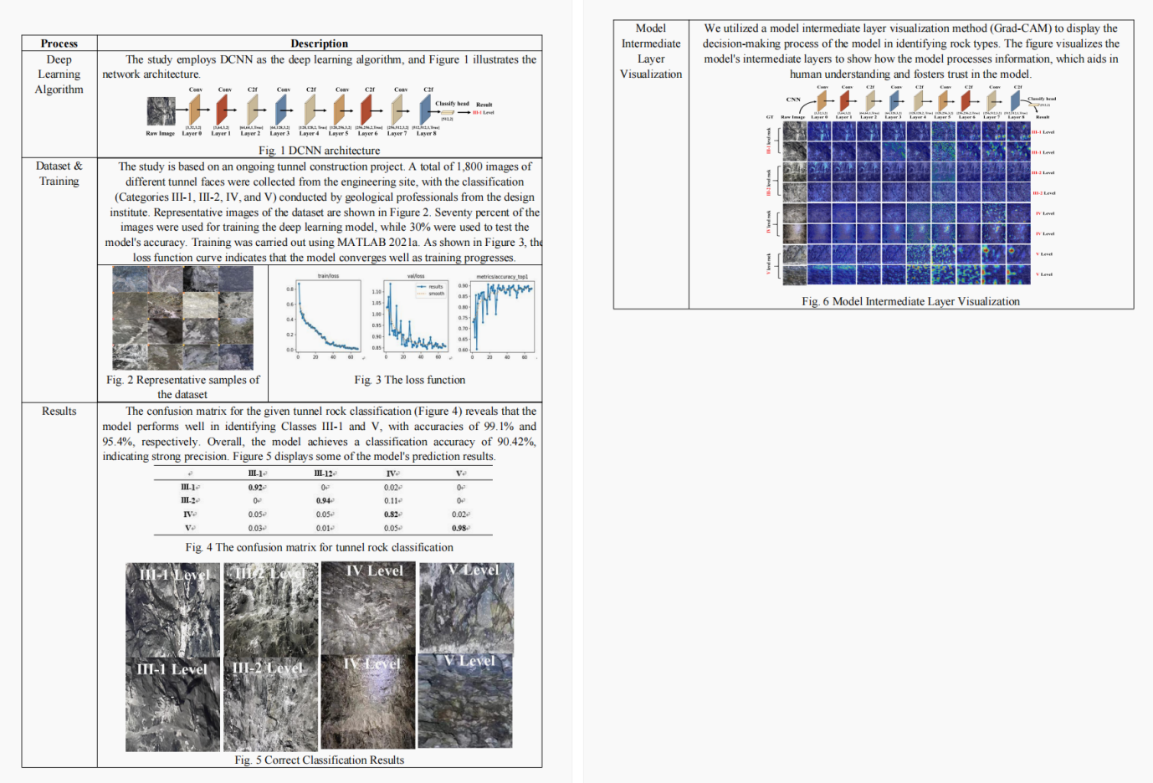

Part 3: Main Questionnaire (Trust in Automation Scale)
This section contains the main measurement instrument of the survey. After reviewing the materials from their assigned experimental condition, all participants were asked to rate the following 19 statements.

3.1 Purpose of this Section
This section uses a validated 5-point Likert scale to quantitatively measure participants' trust in the AI system. The questions are designed to assess multiple dimensions of trust, including Reliability/Competence, Understandability/Predictability, Familiarity, and overall Trust. The aggregated responses from this scale are the primary data used to evaluate the research hypothesis.

3.2 Content as Presented to Participants
Instructions
After reading the above information about the model, please rate the following statements.
Statements
1. The system is capable of accurately predicting the quality of the tunnel face rock mass.
[ ] Strongly disagree
[ ] Somewhat disagree
[ ] Neither agree nor disagree
[ ] Somewhat agree
[ ] Strongly agree
2. The system state was always clear to me.
[ ] Strongly disagree
[ ] Somewhat disagree
[ ] Neither agree nor disagree
[ ] Somewhat agree
[ ] Strongly agree
3. I already know similar rock classification systems based on image analysis andartificial intelligence.
[ ] Strongly disagree
[ ] Somewhat disagree
[ ] Neither agree nor disagree
[ ] Somewhat agree
[ ] Strongly agree
4. The developers who designed the system are trustworthy.
[ ] Strongly disagree
[ ] Somewhat disagree
[ ] Neither agree nor disagree
[ ] Somewhat agree
[ ] Strongly agree
5. One should be careful with unfamiliar automated systems.
[ ] Strongly disagree
[ ] Somewhat disagree
[ ] Neither agree nor disagree
[ ] Somewhat agree
[ ] Strongly agree6. The system works reliably.
[ ] Strongly disagree
[ ] Somewhat disagree
[ ] Neither agree nor disagree
[ ] Somewhat agree
[ ] Strongly agree
7. The system predicts unexpectedly.
[ ] Strongly disagree
[ ] Somewhat disagree
[ ] Neither agree nor disagree
[ ] Somewhat agree
[ ] Strongly agree
8. The developers take my well-being seriously when designing the system.
[ ] Strongly disagree
[ ] Somewhat disagree
[ ] Neither agree nor disagree
[ ] Somewhat agree
[ ] Strongly agree
9. I trust this rock classification prediction systems.
[ ] Strongly disagree
[ ] Somewhat disagree
[ ] Neither agree nor disagree
[ ] Somewhat agree
[ ] Strongly agree
10. The system malfunction is likely.
[ ] Strongly disagree
[ ] Somewhat disagree
[ ] Neither agree nor disagree
[ ] Somewhat agree
[ ] Strongly agree
11. I was able to understand why the system made such predictions.
[ ] Strongly disagree
[ ] Somewhat disagree
[ ] Neither agree nor disagree
[ ] Somewhat agree
[ ] Strongly agree
12. I rather trust a system than I mistrust it.
[ ] Strongly disagree
[ ] Somewhat disagree
[ ] Neither agree nor disagree
[ ] Somewhat agree
[ ] Strongly agree
13. The system can still effectively assess the quality of the rock mass under complexgeological conditions.
[ ] Strongly disagree
[ ] Somewhat disagree
[ ] Neither agree nor disagree
[ ] Somewhat agree
[ ] Strongly agree
14. I can rely on this systems for construction decision-making.
[ ] Strongly disagree
[ ] Somewhat disagree
[ ] Neither agree nor disagree
[ ] Somewhat agree
[ ] Strongly agree
15. The system might make sporadic errors.
[ ] Strongly disagree
[ ] Somewhat disagree
[ ] Neither agree nor disagree
[ ] Somewhat agree
[ ] Strongly agree
16. It’s difficult to identify the prediction results of the system.
[ ] Strongly disagree
[ ] Somewhat disagree
[ ] Neither agree nor disagree
[ ] Somewhat agree
[ ] Strongly agree
17. I have already used similar rock classification prediction systems.
[ ] Strongly disagree
[ ] Somewhat disagree
[ ] Neither agree nor disagree
[ ] Somewhat agree
[ ] Strongly agree
18. Automated systems generally work well.
[ ] Strongly disagree
[ ] Somewhat disagree
[ ] Neither agree nor disagree
[ ] Somewhat agree
[ ] Strongly agree
19. I am confident about the system’s capabilities.
[ ] Strongly disagree
[ ] Somewhat disagree
[ ] Neither agree nor disagree
[ ] Somewhat agree
[ ] Strongly agree

Part 4: Survey Code and Submission
This final part describes the administrative step for survey completion and participant compensation, relevant for platforms like Amazon Mechanical Turk (MTurk).

4.1 Purpose of this Section
This section serves a purely administrative function. It provides participants with a unique completion code, which they must submit to the recruitment platform to verify that they have finished the survey and to receive their payment. This ensures accurate and efficient compensation.

4.2 Content as Presented to Participants
Here is your ID: ${e://Field/Random%20ID}
Copy this value to paste into Mturk.
When you have copied this ID, please click the next button to submit.

